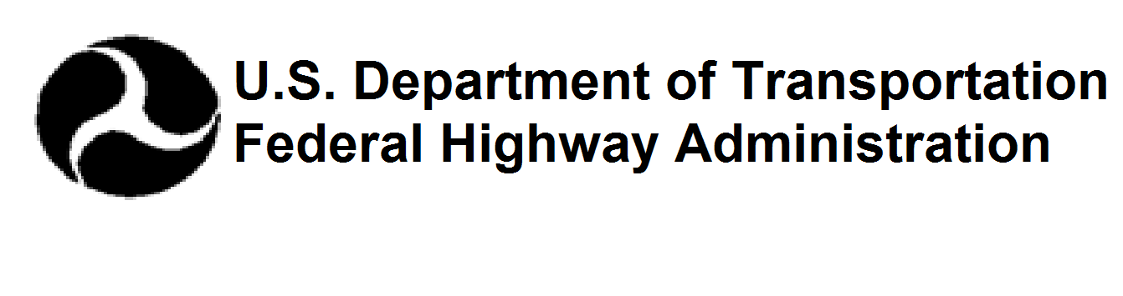

NYS ROUTE 12B
PAVEMENT RECONSTRUCTION AND SAFETY PROJECT
Village of Hamilton, Towns of Hamilton & Madison
PUBLIC INFORMATION MEETING
May 7, 2024
5:30 PM
Hamilton High School Auditorium
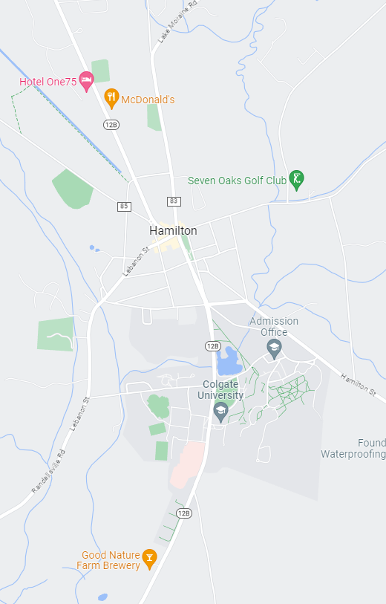
47 W Kendrick Ave, Hamilton, NY 13346
Project Ends:
Wings Way
Project Begins:
Preston Hill Road

PUBLIC INFORMATION MEETING
PIN 2065.39
Route 12b - PAVEMENT reconstruction and safety Project
Village of Hamilton & towns of hamilton & madison, madison County

MEETING PURPOSE
- Present and discuss refined project alternatives
- Answer questions and receive comments

PROJECT PURPOSE & NEED
- Address deteriorated underlaying pavement structure
- Address deteriorated storm drainage system
- Address safety concerns for all users
  - Crash rates exceed statewide average
  - Intersection geometries result in confusion

PROJECT GOALS & OBJECTIVES
- Restore the pavement to good condition
- Restore the drainage storm sewer to good condition
- Enhance safety for all users
- Improve accessibility and mobility for pedestrians and bicyclists
- Incorporate Complete Streets features and promote Active Transportation
- Promote lower speeds within the corridor
- Support economic well-being of the community
- Complement long range plans of the Village and Colgate University

CURRENT PROGRAMMED PROJECT COST
- $14.7 million

PROJECT SCHEDULE
- Preliminary Design Phases (2023/2024)
- Approve Preferred Alternative (Winter 2024)
- Final Design (2025)
- Construction (2026)

OPPORTUNITIES TO COMMENT
Brian R. Hoffmann, P.E.  Regional Design Engineer  207 Genesee Street  Utica, NY 13501  (315) 793-2429 Brian.Hoffmann@dot.ny.gov | Comments may also be e-mailed utilizing the “Contact Us” tab on the project website:  https://www.dot.ny.gov/rt12Breconstruction
 | 
David Facchini, P.E.  Design Teams Manager  (315) 275-3072  David.Facchini@dot.ny.gov | Stefan Widomski, P.E.  Project Team Leader  (315) 793-2298  Stefan.Widomski@dot.ny.gov | Heather Tehan  Public Information Officer  (315) 793-2447  Heather.Tehan@dot.ny.gov

